## Lab 3-13: Provision an RDS Instance

### Lab Prerequisites

* Familiarity with basic AWS Cloud Computing concepts and terminology
* An AWS account with an active subscription

### Service Introduction

AWS-managed database services eliminate licensing expenses and add the ability to support a wide range of database engines. Keep the following types of database technologies in mind while building system architecture:

Relational databases are commonly referred to as RDBS or SQL databases. They are made up of normalized data presented in well-defined tabular structures with rows and columns, referred to as tables. They offer a robust query language, versatile indexing capabilities, strong integrity constraints, and the ability to quickly and efficiently aggregate data from numerous tables.

AWS Relational Database Service (RDS) is a cloud-based managed database server. RDS automates standard database administration activities while providing a cost-effective relational database.

### Case Study Enterprise Retail – Primooz

Background

Primooz was established in the year 2010 by a group of investors in the United Kingdom. The company started selling high-quality foods, medicines, beverages, and fashion products in the United Kingdom. It has grown to become one of the most popular UK online shopping stores, gaining goodwill from shoppers due to its memorable in-store experience.

Primooz offices, manufacturing plants, data centers, and employees are based in the following locations:

* **Head Office in London:** Approximately 100 employees are based at the head office involving strategy, marketing, finance, human resources, technology, and operations
* **Regional Offices:** 3 Regional offices are in Manchester, Liverpool, and Leeds. Each office consists of 5 to 10 employees from Sales and Pre-Sales functions
* **Manufacturing Plants:** 2 Manufacturing plants are based in Liverpool and Shanghai, China
* **Data centers:** Primooz has only one data center in London with 20 x 42U rack space
* **Remote Workforce:** Around 50 sales representatives are hired across the UK to boost sales

Business Challenge

Primooz's business development team is launching a WordPress website for a new e-commerce application. The company was previously using an unmanaged on-premises database for its applications. The team faced several issues with the existing design:

* Maintaining a dedicated team of database engineers
* Management of licenses
* Database failover and recovery

The management has directed the CTO to explore a public cloud option to deal with current challenges.

Proposed Solution

The CTO of Primooz has spoken with multiple cloud and on-premises database solution providers about the current challenges. It has been concluded that Amazon Relational Database Service (Amazon RDS), a fully managed relational database service from AWS, is the best option. It was found that the customers had 39 percent lower database operation costs and a 264 percent return on investment over three years. The option also aligns perfectly with the company's cloud migration strategy.

As a Cloud Engineer, you will help Primooz build a WordPress site using Amazon Relational Database Service.

Lab Diagram

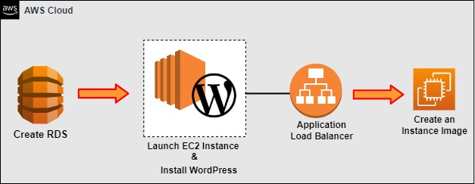

Figure 3-39: Provision RDS Instance

Implementation Steps

1. Create an RDS.
2. Launch EC2 Instance.
3. Install WordPress.
4. Create a Load Balancer.
5. Publish on WordPress.
6. Create an EC2 Instance Image.

### Solution

|  |
| --- |
| **Step 1: Create an RDS**   1. Log in to the **AWS Console.** 2. Go to **Services** and click on **Databases**. Click on **RDS**.      1. Click on **Create a database**.      1. Choose **Standard create** and select **MySQL** in **Engine options**.      1. Select **Template** **Production** as it gives high availability.      1. Now, enter a name for your **DB instance,** create a **username** and enter a **password**.      1. Select **Burstable classes** as your **DB instance class**. 2. Choose **db3.t3.micro**.      1. Now, select **General Purpose (SSD)** as the **storage type** and **Enable storage Autoscaling**.      1. Click on **Choose existing** and deploy **VPC security group** as **default VPC.**      1. Leave other settings as **default**. 2. Click on **Additional Configuration** and enter an **initial database name**. 3. Leave everything else as **default** and click on **Create database**.      1. It can take about **10 – 15 minutes** to be **available**. 2. When the status goes to **Available**, click on the **DB identifier** and view the **Summary**.      1. Next, click on the default **VPC security group**.      1. Click on **Inbound rules** and then **Edit inbound rules**.      1. Click on **Add rule**. 2. Enter Type: **MySQL**, Source type: **Custom**, and in source, choose **WebDMZ** security groups and **Save rules**.     **Step 2: Launch the EC2 Instance**   1. Click **Services**.      1. Select **EC2** from **Compute**.      1. On the left-hand menu, click **Instances.**      1. Click **Launch instances**.      1. In **Step 1: Choose an Amazon Machine Image**, locate **Amazon Linux 2 AMI (HVM), SSD Volume Type**, check **64-bit (x86)**, and click **Select**.      1. In **Step 2: Choose an Instance Type**, select **t2.micro**, and click **Next: Configure Instance Details**.      1. In **Step 3: Configure Instance Details**, enter the following details: 2. Leave everything as **Default**. 3. Scroll down to the **Advanced Details** section. 4. Enter the following code in **Advanced Details**: 5. After adding the **code**, click on **Next : Add Storage**   #!/bin/bash  yum install httpd php php-mysql -y  amazon-linux-extras install -y php7.2  cd /var/www/html  wget https://wordpress.org/wordpress-5.4.1.tar.gz  tar -xzf wordpress-5.4.1.tar.gz  cp -r wordpress/* /var/www/html/  rm -rf wordpress  rm -rf wordpress-5.4.1.tar.gz  chmod -R 755 wp-content  chown -R apache:apache wp-content  service httpd start  chkconfig httpd on   1. Click on **Next: Add Storage**      1. Leave everything by **default**, and go to **Step 5: Add Tags**.   **Key** **Value**  Name WPServer   1. Click on **Next: Configure Security Group**.      1. In **Step 6: Configure Security Group** and select **an existing security group**. 2. Select Security group **WebDMZ**. 3. Click **Review and Launch**.      1. Click **Launch**.      1. In the key pair dialog pop-up, select **Create a new key pair**. 2. Set the **Key pair name** as **WPServerKey**. 3. Click on **Download Key Pair**.      1. Click on **Launch Instances**.      1. Click **View Instances**.     **Step 3: Install WordPress**   1. When the instance state is available as **Running**, click on the instance, copy the **Public IP Address**, and paste it into the web browser.      1. You will be able to see the **WordPress Installation Screen**. 2. Click on **Let’s go**.      1. Enter your **Database name**, **Username, Password, and Database Host**. 2. The database host is the **Endpoint**. Go back to your **database** and copy the endpoint in the clipboard.      1. Paste it in the **Database Host** and press **Submit**.      1. A screen will appear saying **Unable to write to the wp-config.php file**.      1. To further **run the installation**, you need to use **PuTTY** and **PuTTYGen**. 2. Open **PuTTYGen**, click on **Load** and browse the key pair we have installed previously. Now, click on **Save private key** and close.      1. Open **PuTTY** and enter the **Public IP address** in the **Hostname** and **Saved sessions**. Click on **Save**.      1. Next, click on **SSH** and expand it by clicking on the **‘+’** sign. 2. Double-click on **Auth** and browse the private key that you saved earlier. 3. Click on **Open**.      1. Your Terminal will appear saying **Login as**. Now, type **ec2-user** and press **Enter**. 2. Type **sudo su** and press **Enter**. 3. Type **cd /var/www/html** and press **Enter**. 4. Next, type **nano wp-config.php** and press **Enter**.      1. Go back to the **browser** and **copy** the text from the **WordPress installation** page.      1. Paste it into the **terminal** and press **Control + X**.      1. Go back to the browser on the installation page and press **Run the installation.**      1. Now, provide all the information, such as **Site Title**, **Username**, **Password**, and **Email ID**. 2. Then, press **Install WordPress**.      1. You will be able to see that you have successfully installed **WordPress**. Now, click on **Log In**.      1. Enter **username** and **password**, and then press **Log In**.      1. It will bring you to the **Dashboard**. Click on **Settings**.      1. Here, you can see that the **URL** is our **public IP address**.      1. The issue is that the public IP address is tied to the EC2 instance. So if we terminate that EC2 instance, we would get a new public IP address. And WordPress would stop working because it saved this public IP address in the database. Hence, we need the URL to be a DNS address. 2. Our DNS address might be a URL name. So, we can set up an application load balancer and get the DNS address.   **Step 4: Create a Load Balancer**   1. Click on **Services**.      1. Select **EC2** from **Compute**. 2. Scroll down the left-hand pane and select **Load Balancers** under the **Load Balancing** tab.      1. Click **Create Load Balancer**.      1. Select the **type of load balancer**. 2. Click **Create** on the **Application Load Balancer**.      1. Enter a **name** for your load balancer as **WebLoadBalancer**. You will use this load balancer as **internet-facing**, and the address type is **IPv4.**      1. For the **Mappings**, select all the **availability zones** for the **load balancer**.      1. For **Security groups,** select **WebDMZ**.      1. For **Listener**, select **Protocol: HTTP** and **Port: 80**. 2. Select **Create target group**.      1. You will redirect to the **Create target group** page. 2. For **Choose a target type**, select **Instances**. 3. Enter a **Target group name** as **Web servers**.      1. In **Advance health check** **settings**, enter the following values:   **Port: *Traffic port***  **Healthy threshold: *3***  **Unhealthy threshold: *2***  **Timeout: *3***  **Interval: *5***  **Success codes: *200***   1. Click on the **Next** button.      1. In **Available instances**, select **WPServer.** 2. Click on **Create target group**.      1. You will see the **Target group** as **Web servers** being added.      1. Click on **Create load balancer**.      1. The **load balancer** is now successfully **created**.      1. Now, select the newly created Load balancer **WebLoadBalancer**. 2. Copy the **DNS name**.     **Step 5: Publish on WordPress**   1. Go to your **WordPress** page and **paste** it into the **WordPress Address (URL)** and **Site Address (URL)**. 2. Then, click on **Save changes**.      1. Go to the **Posts** and click on **Add New**.      1. Here, you can enter a title, heading, paragraphs, etc. By clicking on **Preview**, you can **view** your page.        1. Click on **Publish** to publish the post.      1. Your post is now **published**.     **Step 6: Create an EC2 Instance Image**   1. Go to the running instance **WPServer**, click on **Actions**, Image, and templates, and **Create image**.      1. Give a **name** to your **image** and click on **Create image**. |

## Lab 3-14: Setup Auto Scaling

### Lab Prerequisites

* Familiarity with basic AWS Cloud Computing concepts and terminology
* An AWS account with an active subscription

### Service Introduction

AWS Auto Scaling continuously monitors your applications and adjusts capacity as needed to ensure consistent, predictable performance at the lowest feasible cost. Using AWS Auto Scaling, you can establish upscaling for numerous resources across multiple services in minutes. AWS Auto Scaling provides a simple, powerful user interface that lets you build scaling plans for Amazon EC2 instances and Spot Fleets, Amazon ECS tasks, Amazon DynamoDB tables, and Amazon Aurora Replicas.

### Case Study Enterprise Retail – Primooz

Background

Primooz was established in the year 2010 by group investors in the United Kingdom. The company started selling high-quality foods, medicines, beverages, and fashion products in the United Kingdom. Now, it has grown to become one of the most popular UK online shopping stores, gaining goodwill from shoppers due to its memorable in-store experience.

Primooz offices, manufacturing plants, datacenters, and employees are based on the following locations:

* **Head Office in London:** Approximately 100 employees are based on head office involving strategy, marketing, finance, human resources, technology, and operations
* **Regional Offices:** 3 Regional offices are in Manchester, Liverpool, and Leeds. Each office consists of 5 to 10 employees from Sales and Pre-Sales functions
* **Manufacturing Plants:** 2 Manufacturing plants are based in Liverpool and Shanghai, China
* **Datacenters:** Primooz has only one datacenter in London with 20 x 42U rack space
* **Remote Workforce:** Around 50 sales representatives are hired across the UK to boost sales

Business Challenge

Primooz's business team is working with AWS services. The development team has created an e-commerce WordPress website. The WordPress website works with RDS, EC2 instance, and application load balancer. The business development team is working on their website's capacity planning and scaling issue. They want a scalable, reliable, and cost-effective solution that facilitates the sudden increase of user traffic. The management has directed the CTO to explore the option of public Cloud to deal with current challenges.

Proposed Solution

Let’s look at what our environment looks like right now. We have our Application Load Balancer; by default, our Application Load Balancers are redundant. So, they are spread across multiple availability zones. Our single EC2 instance is inside a single availability zone, connecting to our primary database, but since we have an RDS Multi-AZ turned on, we also have a secondary database in another availability zone. It is a single point of failure. So, we are going to terminate this instance. We will then create an auto scaling group using that AMI (Amazon Machine Image) we just created.

Lab Diagram

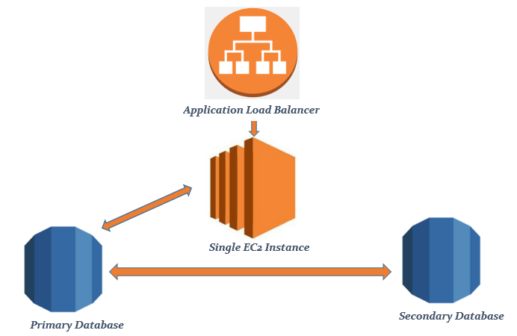

Figure 3-47: Lab Diagram

Implementation Steps

1. Terminate the EC2 Instance.
2. Create Launch Configuration.
3. Create Auto Scaling Group.

### Solution

1. Go to your EC2 instances and click on the instance that you created.

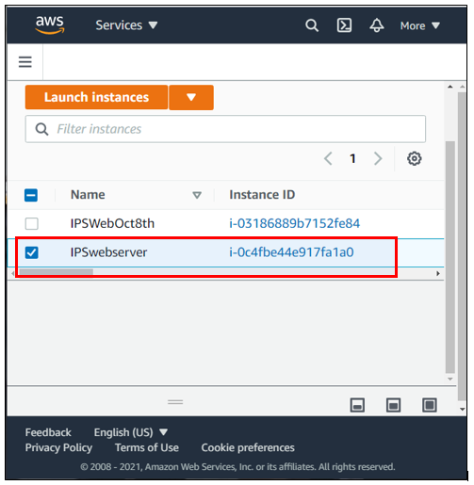

2. Click on “Instance state” and click “Terminate instance”.

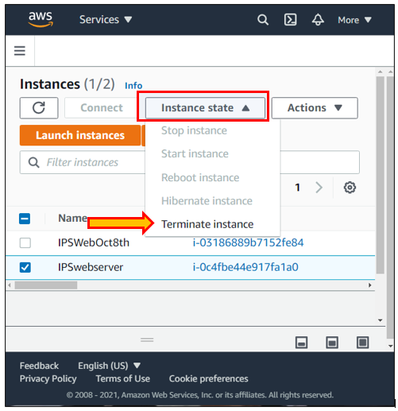

3. Go to EC2 and click on Launch Configurations under Auto Scaling. Click on “Create Launch Configuration”.

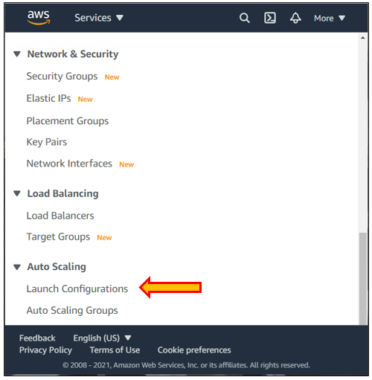

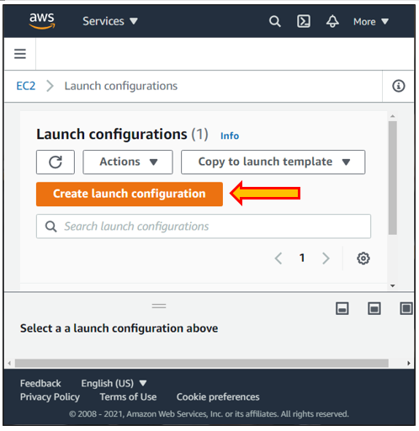

4. Go to AMI and select the AMI that you previously created from My AMIs.

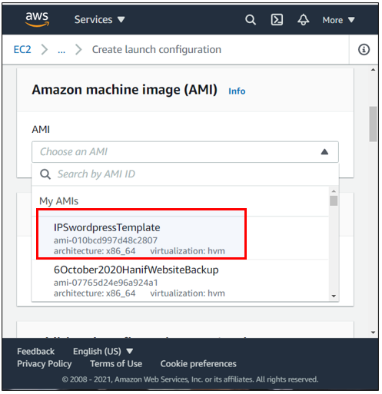

5. Give a name to your configuration.

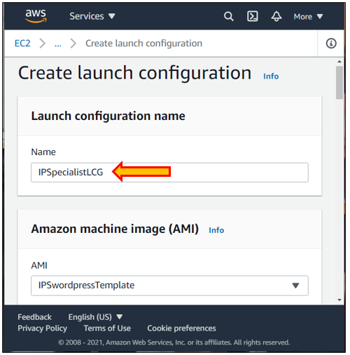

6. Choose instance type.

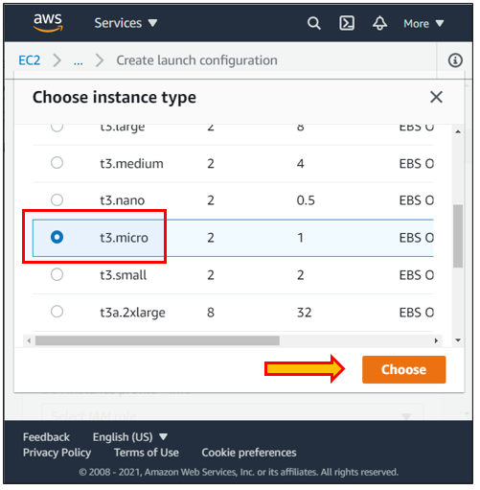

7. Write a small Bootstrap script under user data.

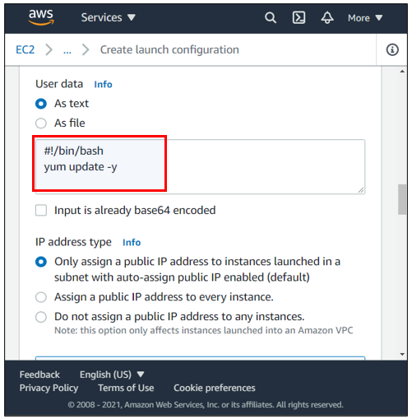

8. Click “Next” and select an existing security group of WebDMZ.

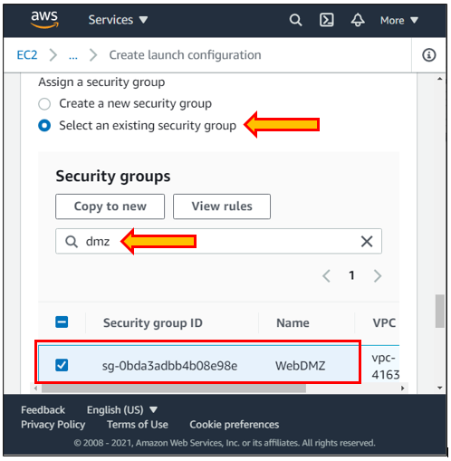

9. Choose an existing key pair, or you can also create a new key. Then, click on Create launch configuration.

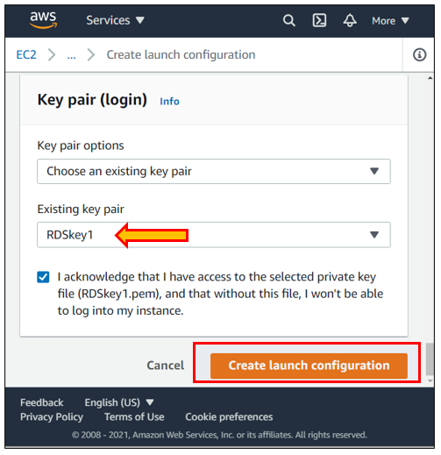

10. You will receive a notification stating: “Successfully created launch configuration”.

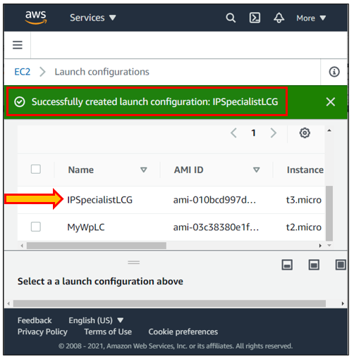

11. Now go to EC2, click “Auto scaling Groups” under Auto scaling, and create an auto scaling group.

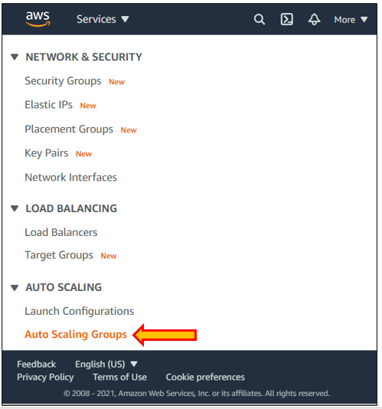

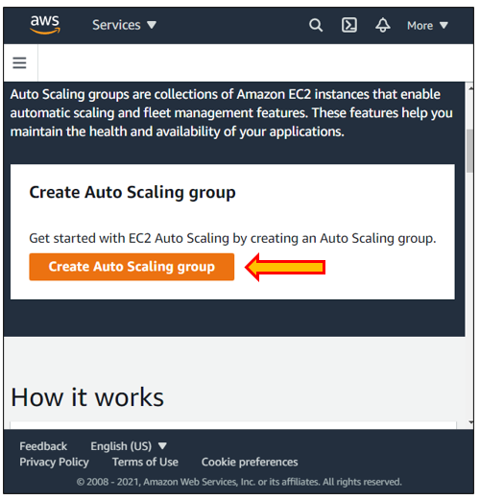

12. Name the auto scaling group and choose a launch configuration. Then click “Next”.

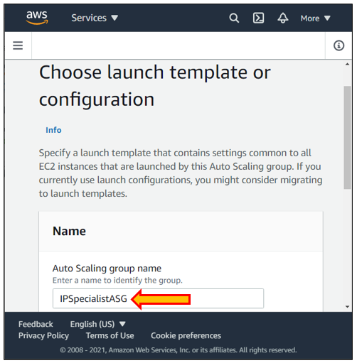

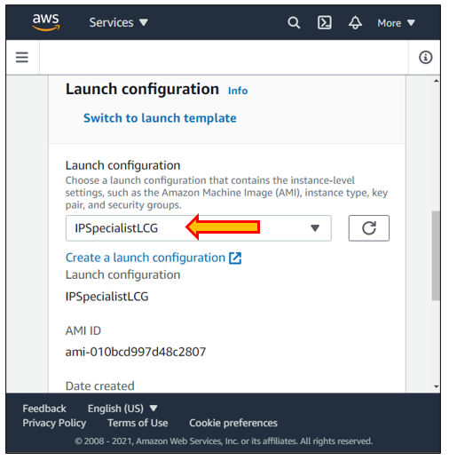

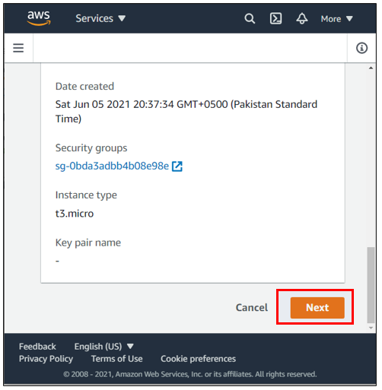

13. Now, choose default VPC and select all the subnets present. Auto scaling launches one EC2 instance in one subnet or one availability zone then automatically launches the second one in a completely different one. So, it is already pre-configured that Auto scaling spreads the EC2 instances across multiple availability zones.

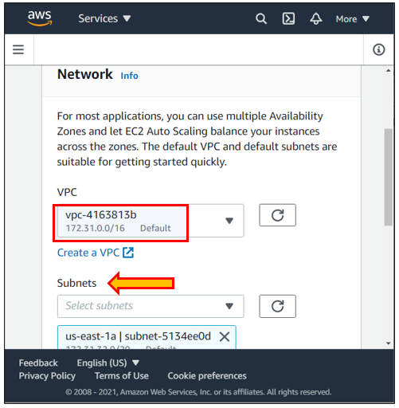

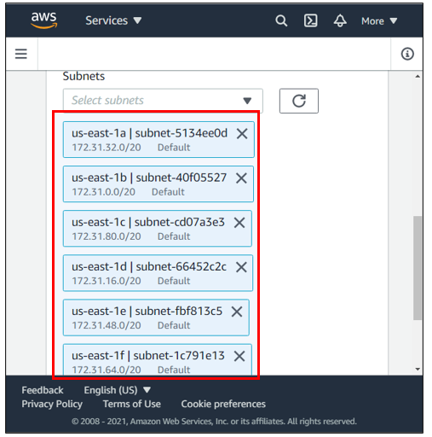

14. Click “Attach to an existing Load balancer”.

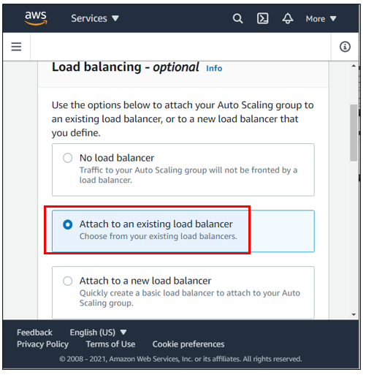

15. Next, choose from your load balancer target groups.

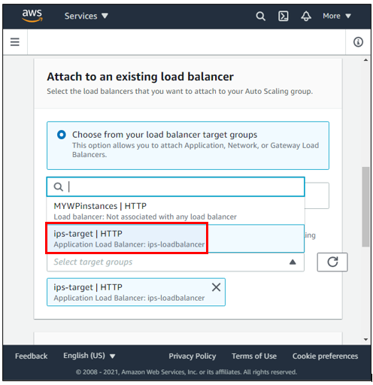

16. Click and check the box of ELB. Then, click on “Next”.

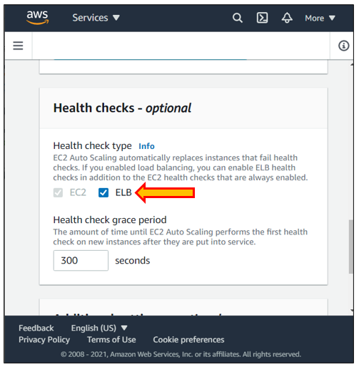

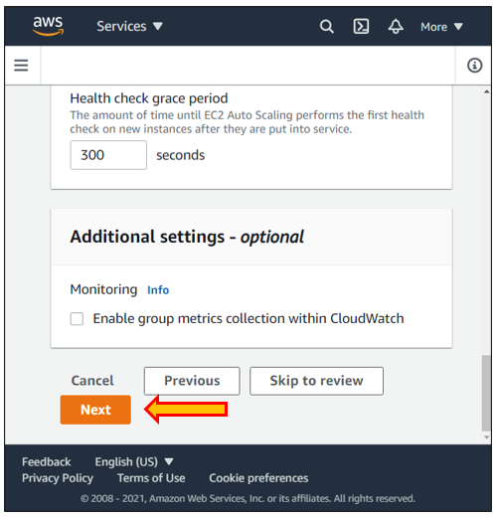

17. Now, specify the size of the auto scaling group.

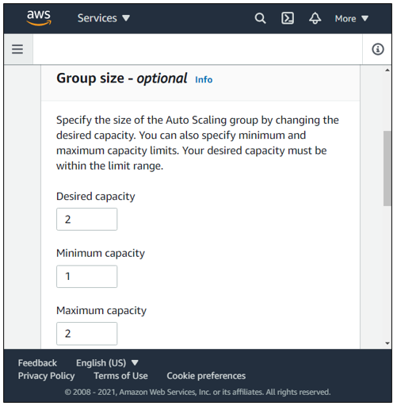

18. Choose the scaling policy and enter the target value of 90. Click “Next”.

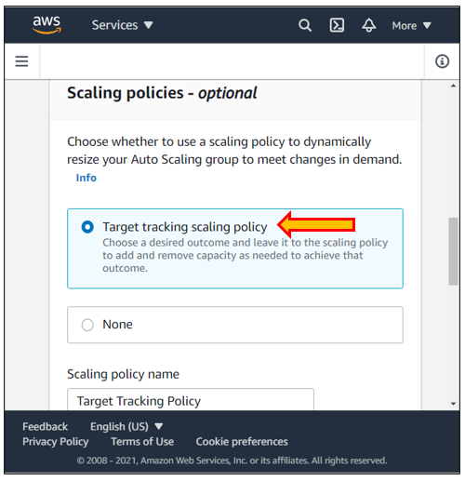

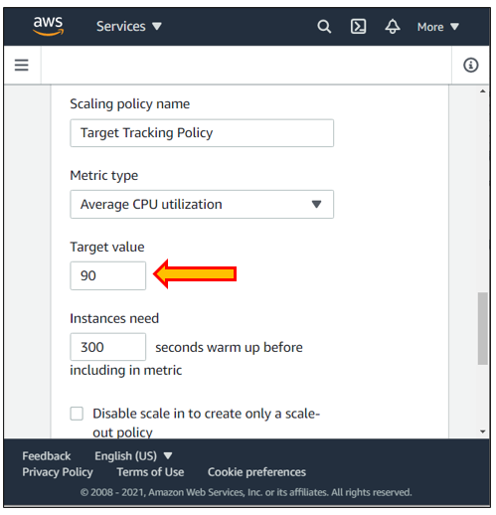

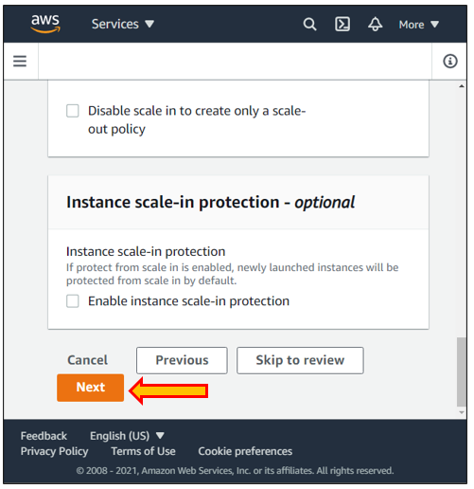

19. Leave everything as default in the notification configuration and tag configuration page, then click “Next”.

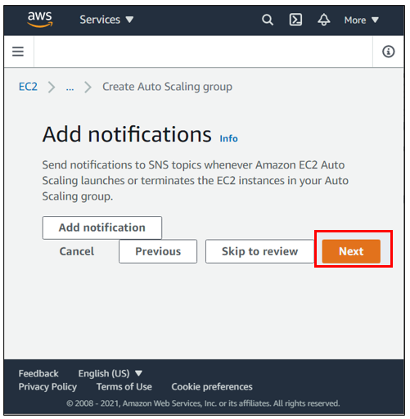

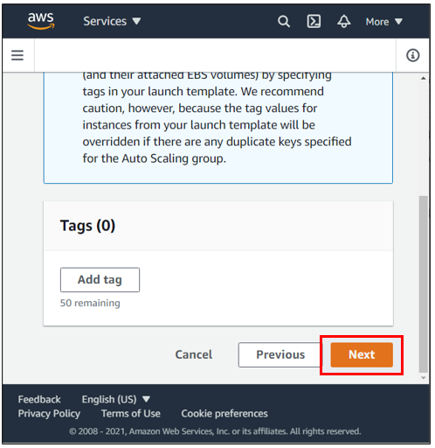

20. Here, you can review the auto scaling group.

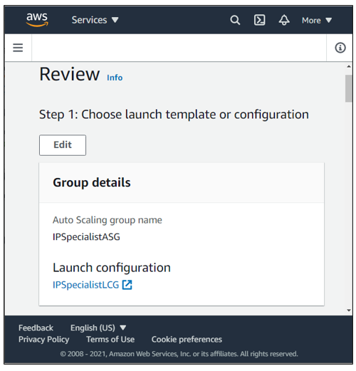

21. Click on “Create Auto Scaling group,” and you will receive a notification stating that the scaling policy has been created successfully.

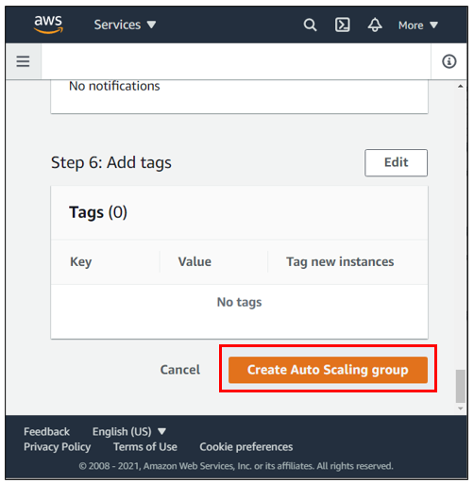

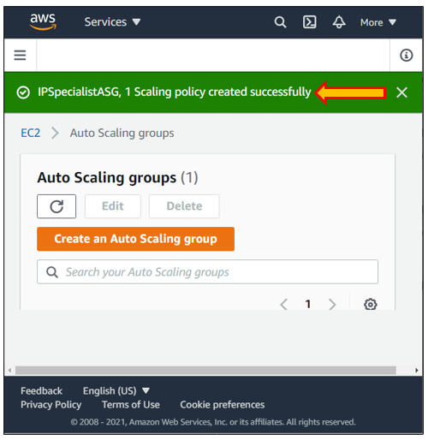

22. Now, go back to “Load Balancers”, copy the DNS name, and paste it into a new tab.

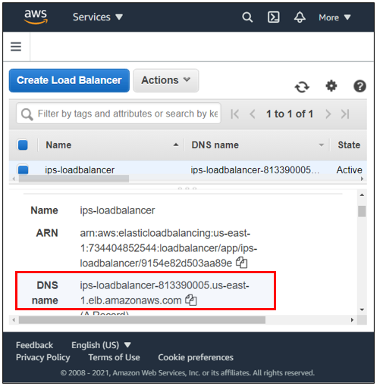

23. Your WordPress site will appear. This WordPress site is behind an Application Load Balancer two EC2 instances in multiple availability zones.

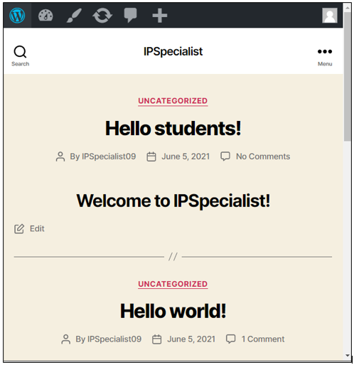

## Lab 3-15: Register a Domain Name

### Lab Prerequisites

* Familiarity with basic AWS Cloud Computing concepts and terminology
* An AWS account with an active subscription

### Service Introduction

Amazon Route 53 is a cloud Domain Name System (DNS) web service that is highly accessible and scalable. Its purpose is to provide developers and organizations with a highly reliable and cost-effective solution to route end users to Internet applications by translating domain names such as www.example.com into numeric IP addresses such as 192.0.2.1. As a result, Amazon Route 53 is completely IPv6 compatible.

### Case Study Enterprise Retail – Primooz

Background

Primooz was established in the year 2010 by group investors in the United Kingdom. The company started selling high-quality foods, medicines, beverages, and fashion products in the United Kingdom. Now, it has grown to become one of the most popular UK online shopping stores, gaining goodwill from shoppers due to its memorable in-store experience.

Primooz offices, manufacturing plants, data centers, and employees are based on the following locations:

* **Head Office in London:** Approximately 100 employees are based at the head office involving strategy, marketing, finance, human resources, technology, and operations
* **Regional Offices:** 3 Regional offices are in Manchester, Liverpool, and Leeds. Each office consists of 5 to 10 employees from Sales and Pre-Sales functions
* **Manufacturing Plants:** 2 Manufacturing plants are based in Liverpool and Shanghai, China
* **Data centers:** Primooz has only one data center in London with 20 x 42U rack space
* **Remote Workforce:** Around 50 sales representatives are hired across the UK to boost sales

Business Challenge

Primooz's business development team has launched a WordPress website for a new e-commerce application. The company has completed its web deployment using various AWS services. The company has decided to upgrade its website with registered domain names. The management has directed the CTO to explore the solution within the AWS Cloud services.

Proposed Solution

CTO of Primooz has decided to register a domain name by using Amazon Route 53. Amazon Route 53 is a cloud Domain Name System (DNS) web service that provides developers and organizations with a highly reliable and cost-effective solution to route end users to Internet applications by translating domain names. In this solution, Primooz's official website www.primooz.com will be translated into numeric IP addresses such as 192.0.2.1.

As a Cloud Engineer, you will help Primooz register a domain name using Amazon Route 53 Service.

Lab Diagram

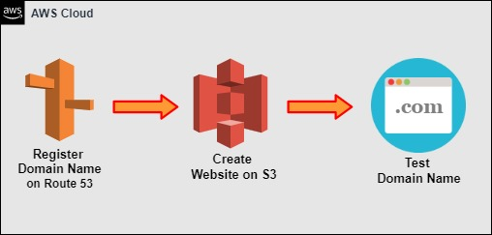

Figure 3-48: Lab Diagram

Implementation Steps

1. Search a Domain name.
2. Create a Website on S3.
3. Buy a Domain name.
4. Create a Record.
5. Test out the Domain name.

### Solution

1. Log in to the AWS console

2. Click on “Services” and go to “Route 53”.

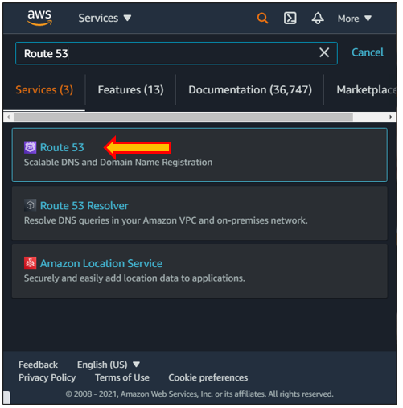

3. Click on “Domain registration” and register a Domain.

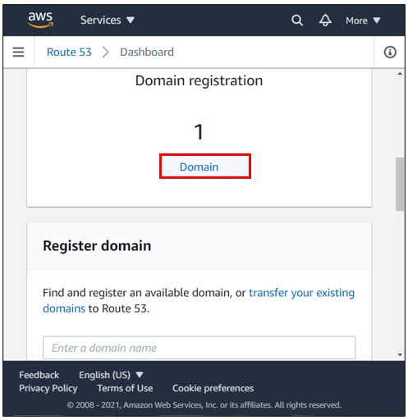

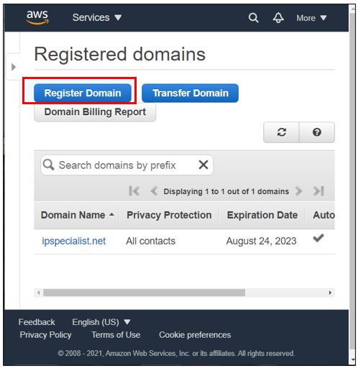

4. Choose a domain name and see if that domain is available.

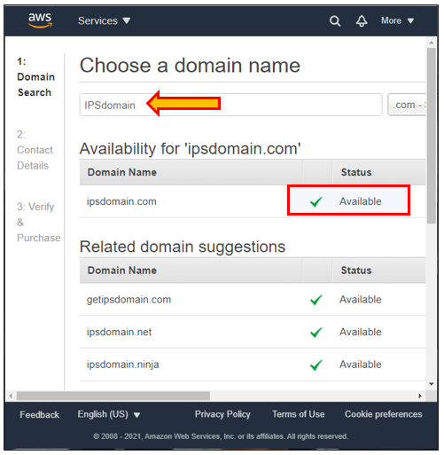

5. Go to “Services” and click on “S3”.

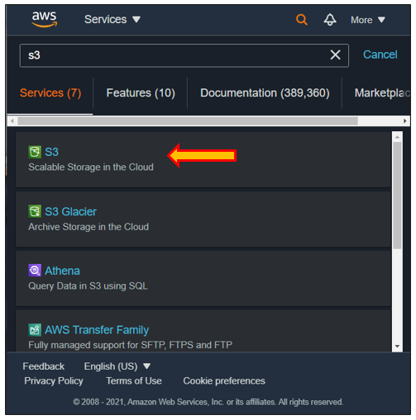

6. Click on “Buckets” and create a bucket.

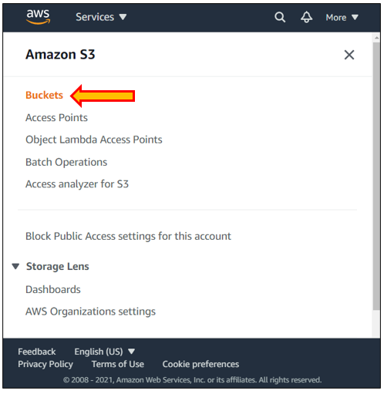

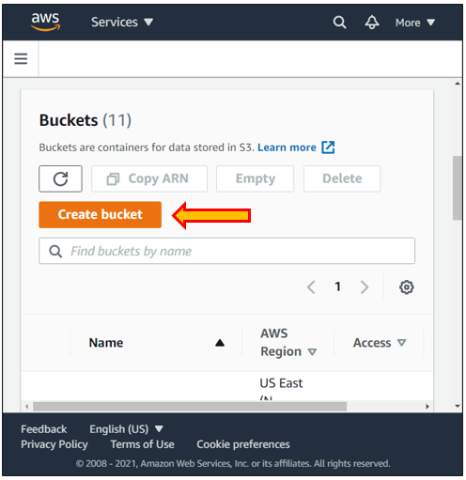

7. Give a name to your bucket. Then, edit the public access settings, uncheck the block option, and acknowledge the settings you have changed.

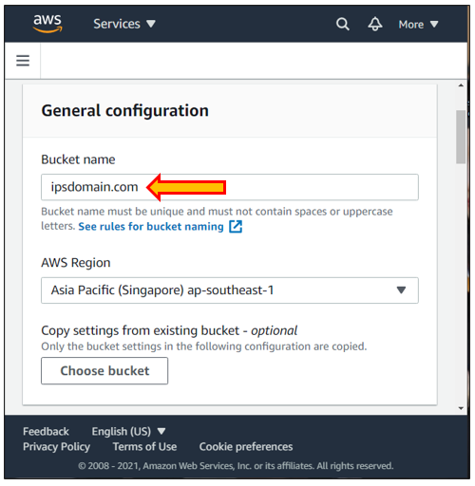

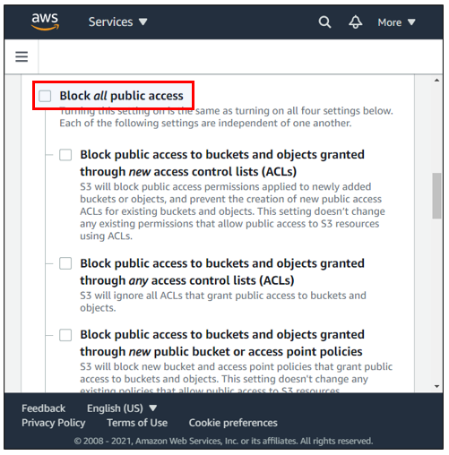

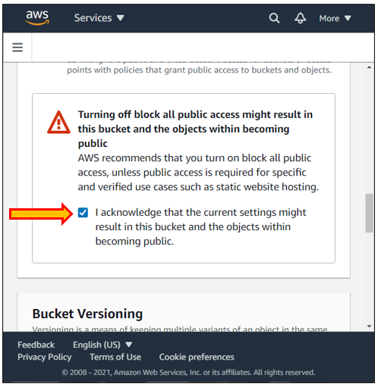

8. Next, disable the bucket versioning and create a bucket.

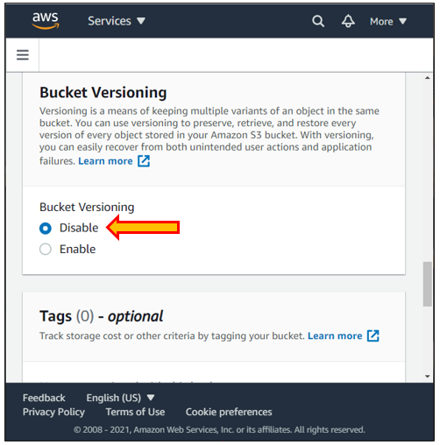

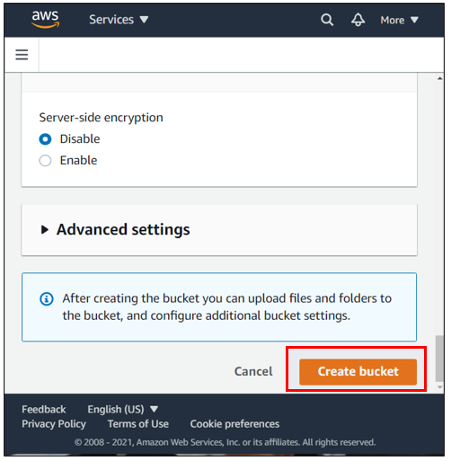

9. You will receive a notification stating that you have successfully created a bucket.

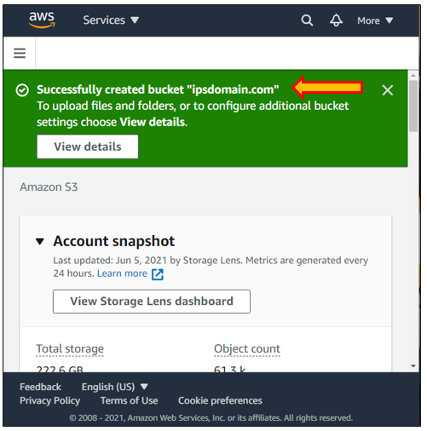

10. Click on the bucket you have created, go to properties, and edit the Static Website Hosting.

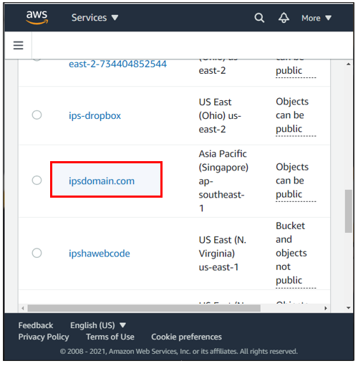

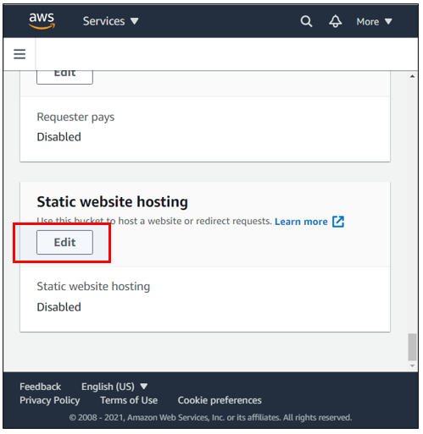

11. Enable the Static website hosting and choose the hosting type.

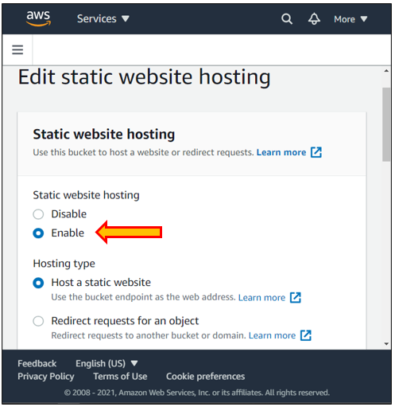

12. Next, type index.html in the index document and error.html in the error document. Click on “Save changes”.

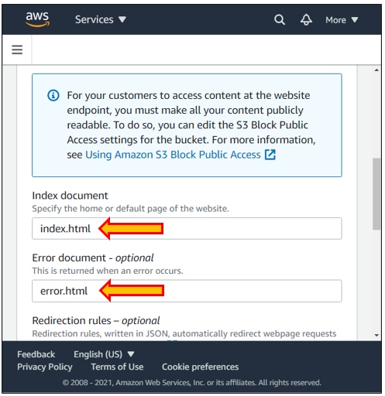

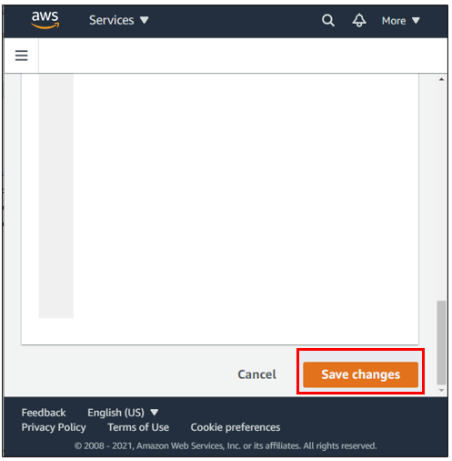

13. Click “Permissions” and edit the bucket policy.

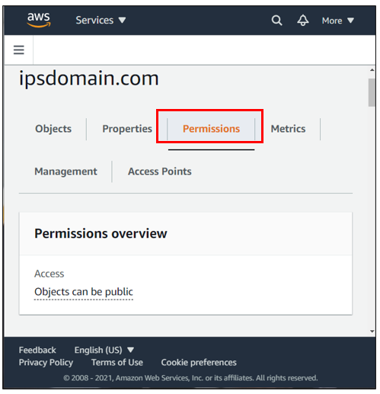

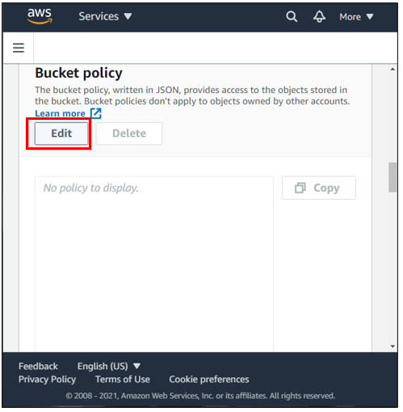

14. Copy and paste the following permission policy.

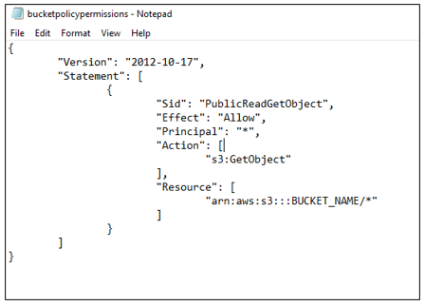

15. Copy the Bucket ARN and paste it into the policy. Click “Save changes”.

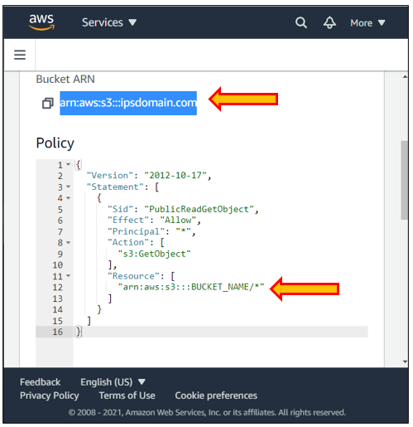

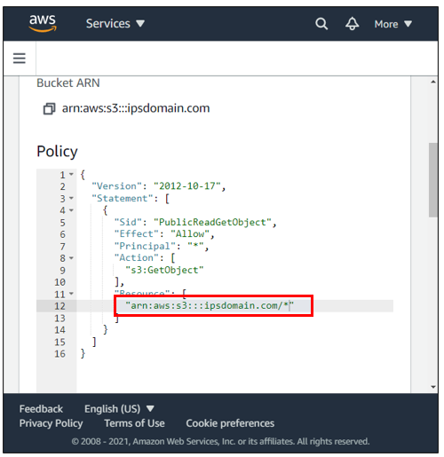

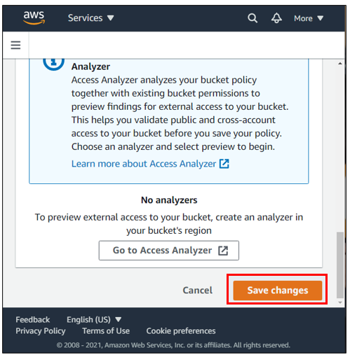

16. You will get a notification stating that you have successfully edited the bucket policy, and it is also publicly accessible.

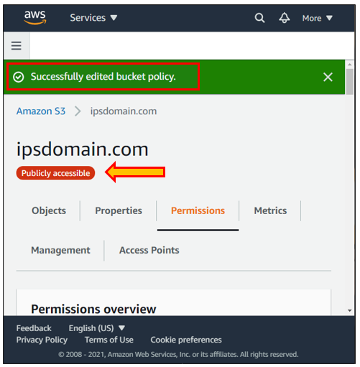

17. Now, upload the error.html and index.html file.

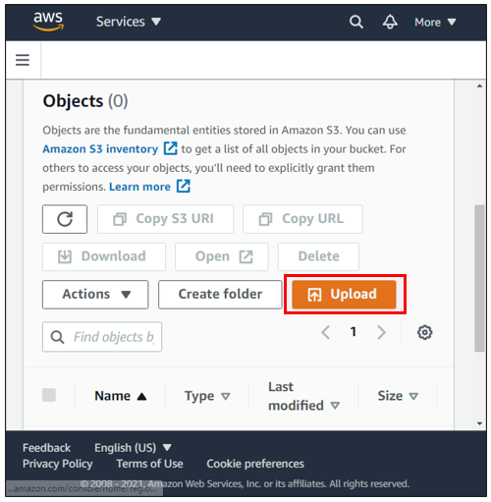

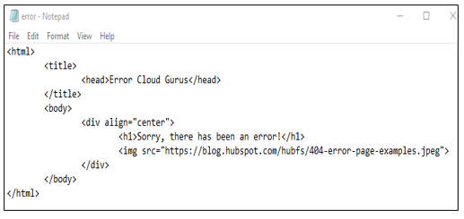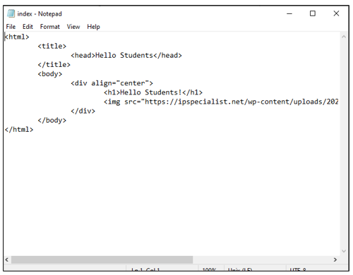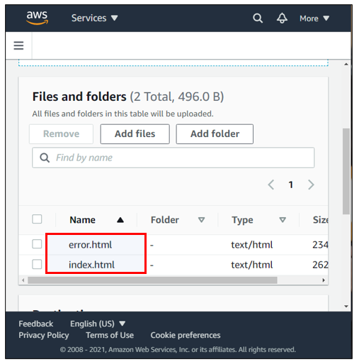

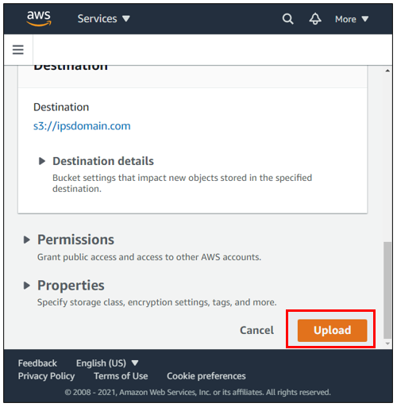

18. You will receive a notification stating: “Upload succeeded”.

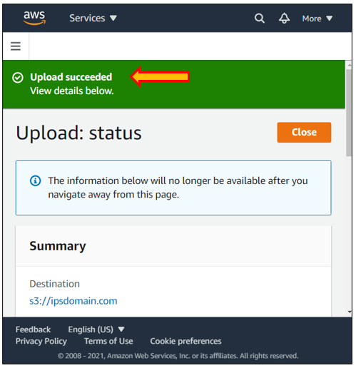

19. Go to S3. You will notice that the domain is now public.

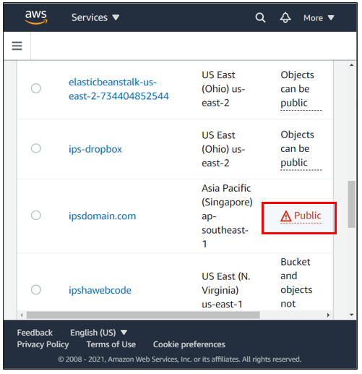

20. Go to route 53 and add your domain to the cart. Click “Continue”.

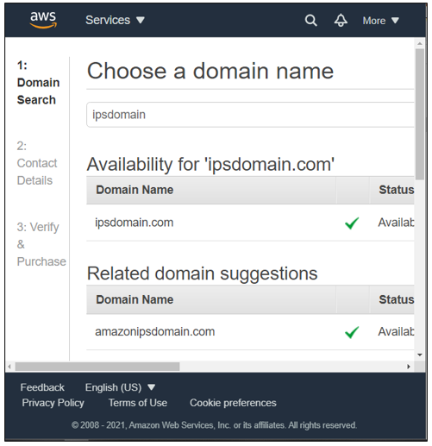

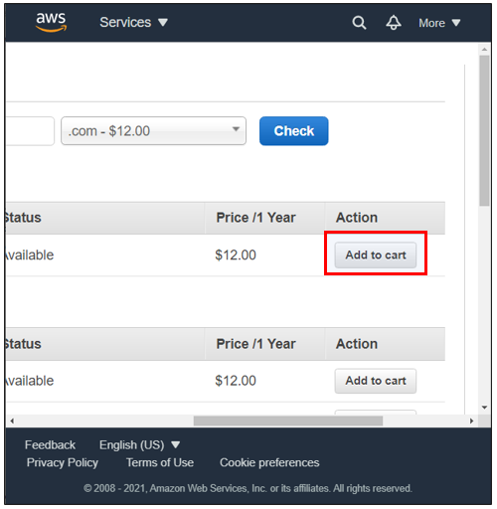

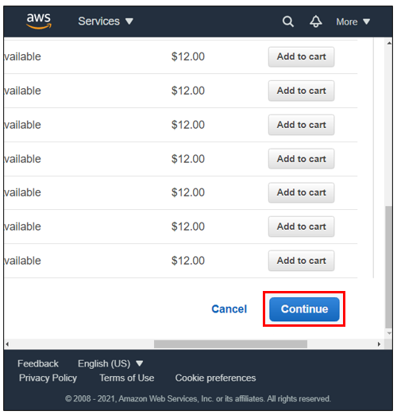

21. Now, enter the information of the registrant. Click “Continue”.

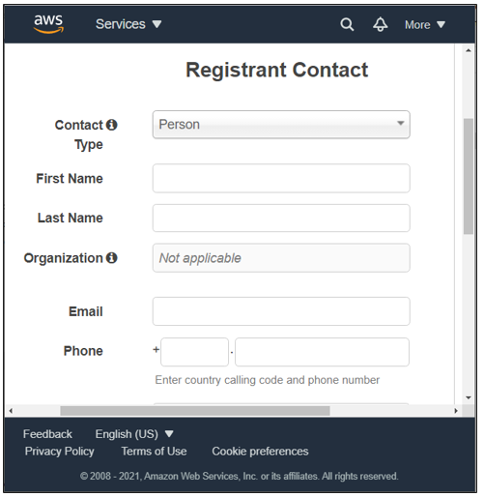

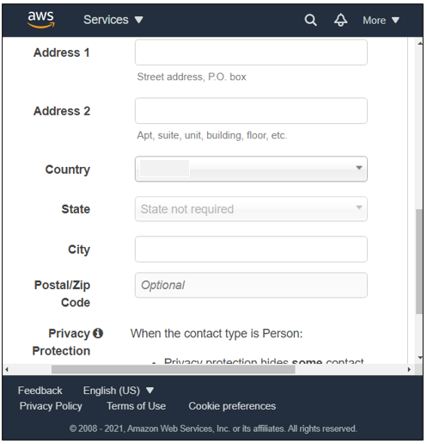

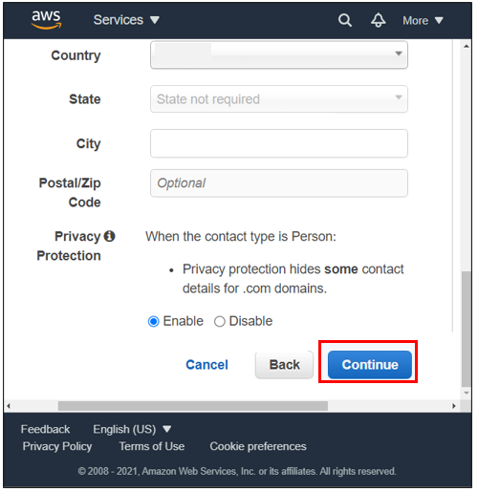

22. Agree to the terms and conditions after reading them. Then, click on “Complete Order”.

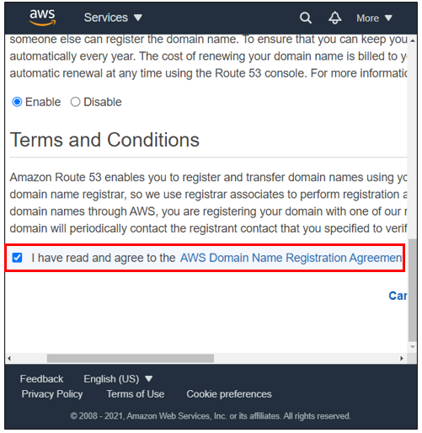

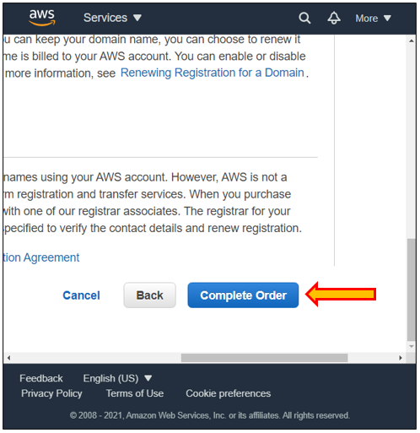

23. Notification will appear stating: “Order submitted successfully”.

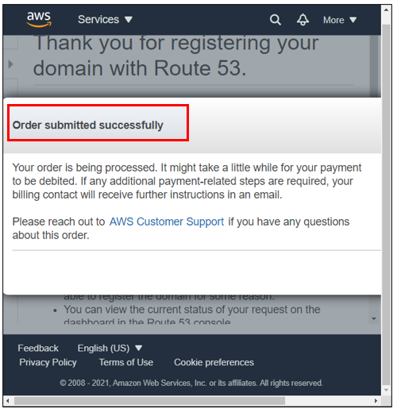

24. Go to Domains. You will notice that the registration is in progress. It can take up to 30 min to 1 hour.

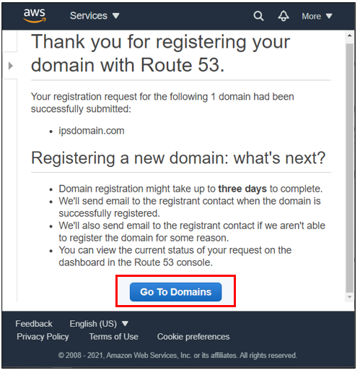

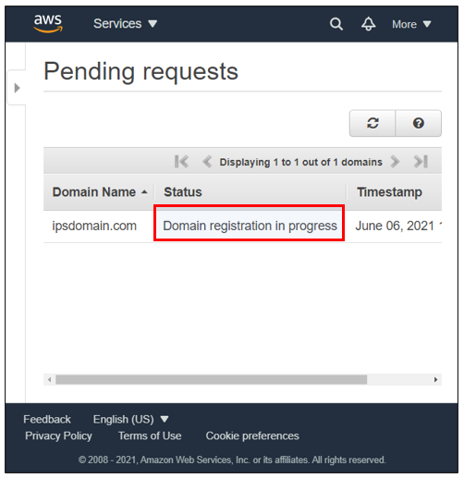

25. Once the registration is successful, click “Hosted zones”.

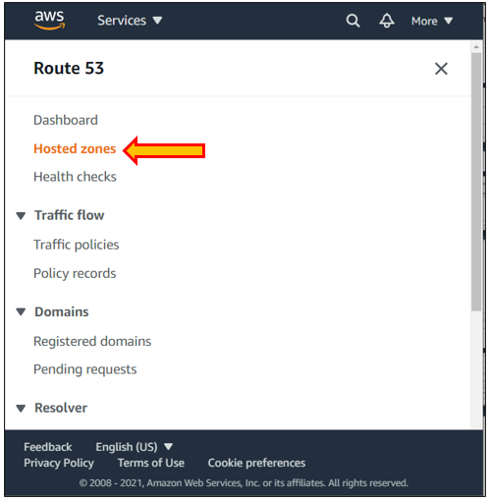

26. Click on the domain and create a record.

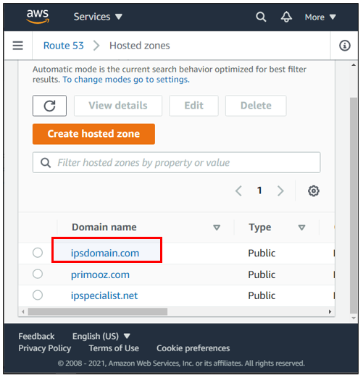

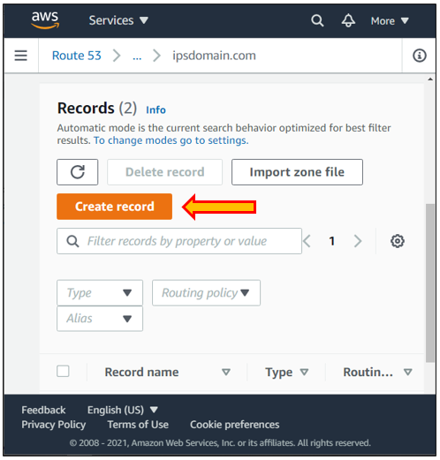

27. Choose IPV4 as the record type. Turn on the alias and enter the information. Choose “Simple routing policy”. Click on “Create records”.

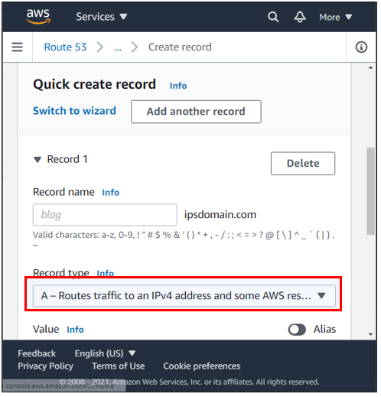

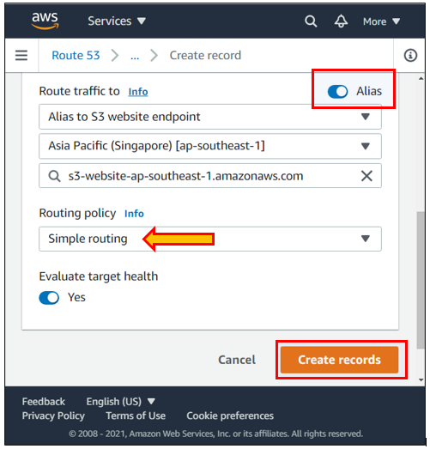

28. Record has been successfully created.

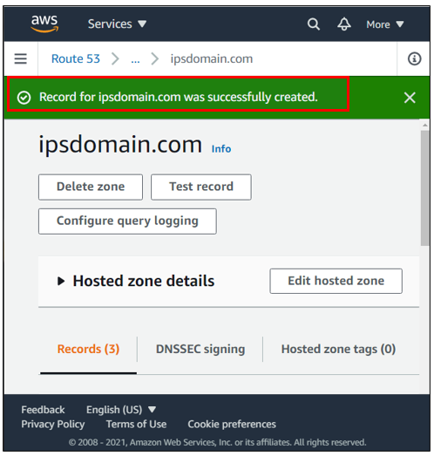

29. Open a new tab and enter your domain name. You will see the content of your index.html file.

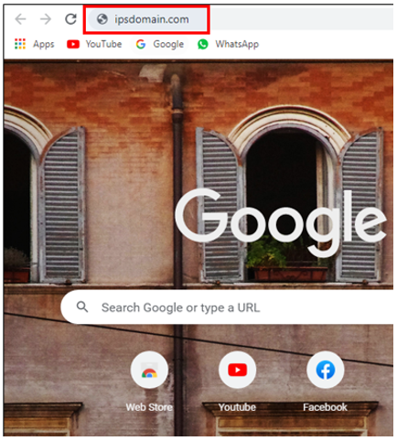



30. If you write anything else along with your domain name, you will get an error. It is the error.html file you uploaded previously.

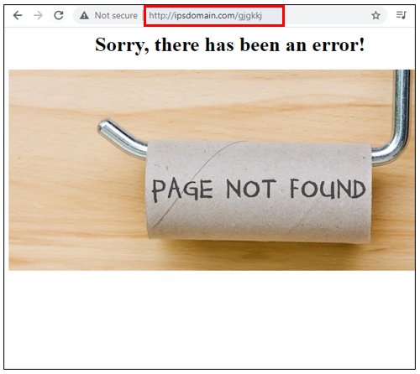

## Lab 3-16: Elastic Beanstalk

**Lab Prerequisites**

* Familiarity with basic AWS Cloud Computing concepts and terminology
* An AWS account with an active subscription

### Service Introduction

AWS Elastic Beanstalk is a simple tool for delivering and scaling web applications and services written in Java, .NET, PHP, Node.js, Python, Ruby, Go, and Docker on well-known servers like Apache, Nginx, Passenger, and IIS.

Simply upload your code, and Elastic Beanstalk will take care of everything else, including capacity provisioning, load balancing, auto scaling, and application health monitoring. At the same time, you retain complete control over the AWS resources that power your application and may access them at any time.

### Case Study Enterprise Retail – Primooz

Background

Primooz was established in the year 2010 by group investors in the United Kingdom. The company started selling high-quality foods, medicines, beverages, and fashion products in the United Kingdom. Now, it has grown to become one of the most popular UK online shopping stores, gaining goodwill from shoppers due to its memorable in-store experience.

Primooz offices, manufacturing plants, datacenters, and employees are based on the following locations:

* **Head Office in London:** Approximately 100 employees are based at the head office involving strategy, marketing, finance, human resources, technology, and operations
* **Regional Offices:** 3 Regional offices are in Manchester, Liverpool, and Leeds. Each office consists of 5 to 10 employees from Sales and Pre-Sales functions
* **Manufacturing Plants:** 2 Manufacturing plants are based in Liverpool and Shanghai, China
* **Datacenters:** Primooz has only one datacenter in London with 20 x 42U rack space
* **Remote Workforce:** Around 50 sales representatives are hired across the UK to boost sales

Business Challenge

Primooz's business development team is launching a WordPress website for a new e-commerce application. The website is performing well in day-to-day life and as well as on peak days. The management has realized that the website consumes a lot of computing power and the developer's time to be operational. The management is now looking for a solution that requires less human effort and provides hassle-free web deployment.

The management has directed the CTO to explore the AWS Cloud provider solution to deal with the current challenge.

Proposed Solution

The CTO of Primooz has spoken with a number of Cloud and on-premises web solution providers about the current challenges. It has been concluded that AWS Elastic Beanstalk provides a simple environment in which you can develop and deploy your applications while Beanstalk takes care of many of the complexities; hence it is the best option for the current requirements. AWS can remove a lot of the setup work from development/deployment, saving time and effort for developers and businesses. AWS Elastic Beanstalk is an orchestration service that abstracts away some of these physical resources and technicalities while still giving developers a variety of OS and programming language options.

Lab Diagram

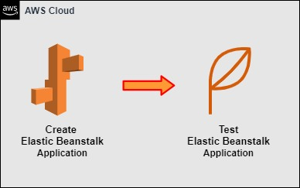

Figure 3-49: Lab Diagram

Implementation Steps

1. Create an Application in Elastic Beanstalk.
2. Test out the Application.

### Solution

1. Log in to the AWS console.

2. Click on “Services” and go to “Elastic Beanstalk”. Then, click on “Create Application”.

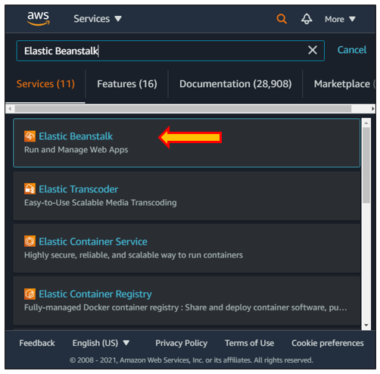

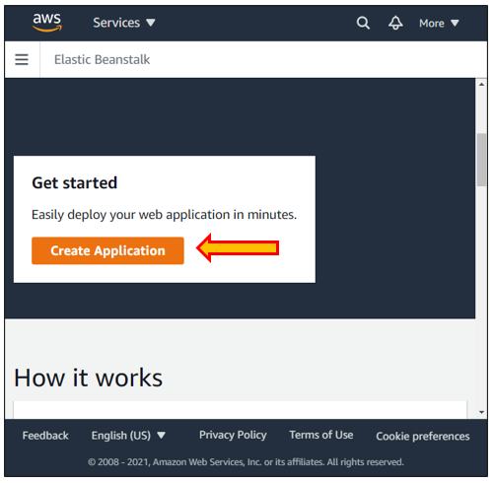

3. Give a name to your application and choose the PHP platform.

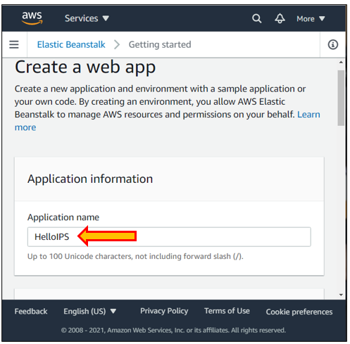

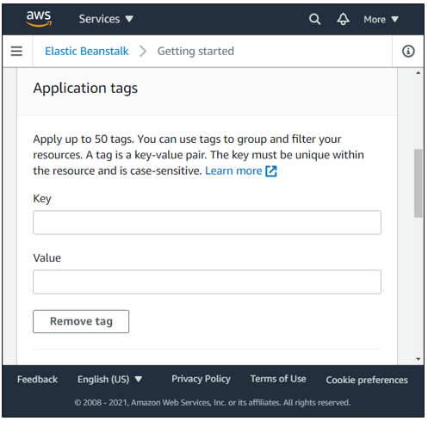

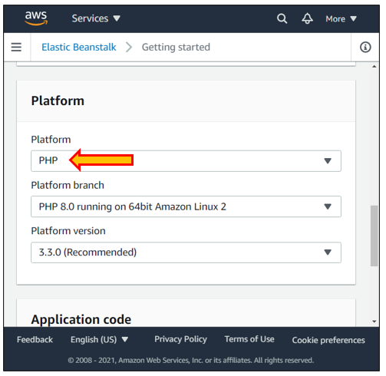

4. Choose a sample application as an application code. Click on “Create application”.

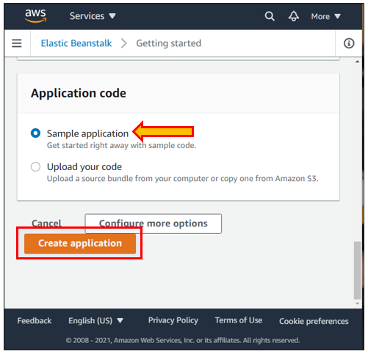

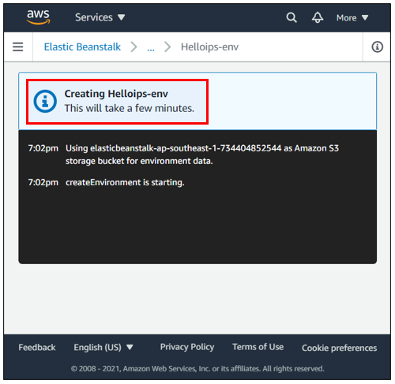

5. When the application is successfully created, click on the URL and view your application environment.

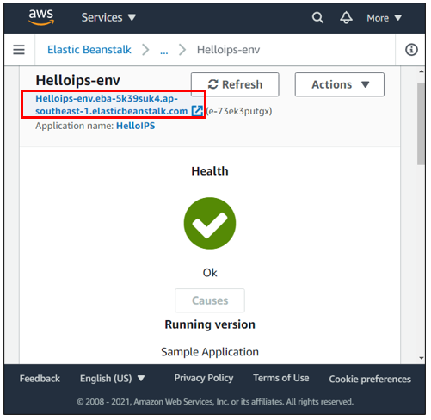

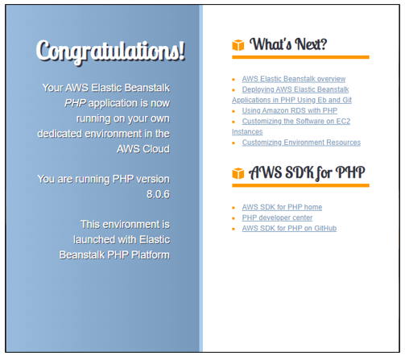

## Lab 3-17: Creating an SNS Topic and Subscribing through Email

### Lab Prerequisites

* Familiarity with basic AWS Cloud Computing concepts and terminology
* An AWS account with an active subscription

### Service Introduction

Amazon Simple Notification Service (Amazon SNS) is a web service that makes it simple to set up, manage, and deliver cloud alerts. It allows developers to publish applications' messages and quickly distribute them to subscribers or other apps in a highly scalable, flexible, and cost-effective manner. It is intended to make web-scale computing more accessible to developers. Amazon SNS adheres to the "publish-subscribe" (pub-sub) communications paradigm, with alerts given to clients using a "push" technique that eliminates the need to check or "poll" for new information and changes regularly. Amazon SNS provides developers with an easy way to include a robust notification system in their applications. Simple APIs require no up-front development work, maintenance or administrative costs, and pay-as-you-go pricing.

Amazon SNS is quite simple to use. Developers must first build a "topic" that serves as an "access point" – designating a specific subject or event type – for posting messages and allowing clients to subscribe to notifications. After creating a topic, the topic owner can define its regulations, such as who can publish messages or subscribe to alerts or support notification protocols (e.g., HTTP/HTTPS, email, SMS). Subscribers are clients who want to be notified about subjects of interest; they can subscribe to a topic or be subscribed to by the topic owner. Subscribers indicate the protocol and endpoint (URL, email address, etc.) to which alerts should be delivered. When publishers have information or changes to share with their subscribers, they may post a message to the subject, which immediately causes Amazon SNS to distribute the message to all relevant subscribers.

Event notification, monitoring applications, workflow systems, time-sensitive information updates, mobile apps, and any other application that creates or consumes alerts may all be supported by the Amazon SNS service. Amazon SNS, for example, can be used in workflow systems to relay events across remote computer software, transport data between data storage, or update records in business systems. Event updates and alerts about validation, approval, inventory changes, and shipping status are given instantly to relevant system components and end-users. A popular technique is to utilize SNS to publish messages to Amazon SQS message queues to transmit messages asynchronously to one or more system components. Another example of how Amazon SNS may be used is to convey time-sensitive events to mobile applications and devices. Because Amazon SNS is highly dependable and scalable, it offers considerable benefits to developers who create real-time event-based systems.

### Case Study – WillyWeather Runs Nowcasting Model for Weather Predictions Using AWS SNS

Background

WillyWeather is one of Australia's major weather forecast suppliers and serves consumers in the United Kingdom and the United States. In 2020, it created a nowcasting model that predicts rain and small-scale storms using real-time data from 70 radars around Australia. Since 2018, the organization has used Amazon Web Services (AWS) and approached AWS for assistance in developing its nowcasting alert system.

Business Challenge

WillyWeather develops reliable rain notifications, whether for leisure pursuits or outdoor business, which may significantly influence people's behavior and organizations' capacity to adjust to adverse weather. On the other hand, weather forecasting is a highly changeable activity susceptible to capricious influences. Traditional weather predictions assist individuals in making weekend plans, but the models seldom give a realistic picture of short-term weather changes. Nowcasting improves short-term weather forecasting by producing location-specific forecasts for the next 0 to 6 hours.

Proposed Solution

The nowcasting models use AWS Lambda serverless programming with real-time radar imaging data. AWS Lambda activates the nowcasting model when rain is detected, making weather forecasts every 2 minutes and storing the actual weather for comparison. WillyWeather stores accurate and forecasted data in Amazon Simple Storage Service (Amazon S3) at a minimal cost.

WillyWeather's 5 million active monthly customers receive weather notifications via Amazon Simple Notification Service (Amazon SNS) on their mobile devices. The organization employs Amazon Simple Queue Service (Amazon SQS) to handle notification queues at scale, ensuring that notifications are relayed without delay.

Its technical team also configured notifications in Amazon CloudWatch to get notifications of any unusual behavior, such as failed notifications. "Having direct access to AWS key solution architects aided us in determining the best service and product for each use case." Together with Intellify's experience in developing AI and ML-based systems, it has contributed to the success of our nowcasting project," Allen explains.

***Lab Diagram***

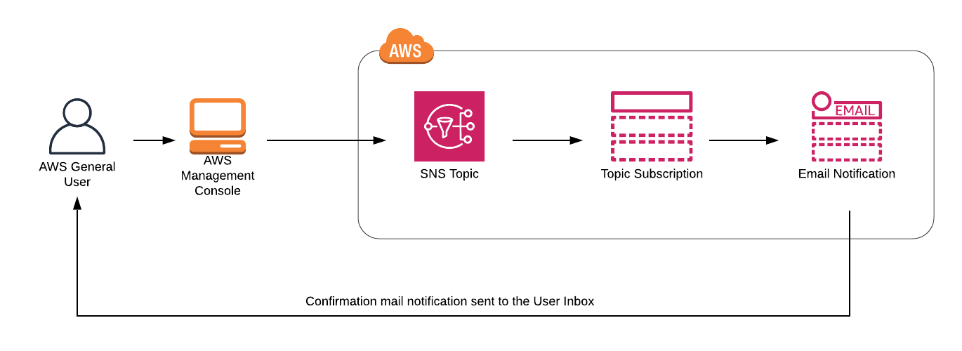

Figure 3-51: Creating an SNS Topic and Subscribing through Email

Implementation Steps

1. Create an SNS Topic.

2. Subscribe to email notifications while creating SNS Topic.

### Solution

|  |
| --- |
| **Step 1: Create an SNS Topic**  1. Log in to the **AWS Management Console**.  2. Go to **Services** and click on **Application Integration**. Click on **SNS.**    3. Click on the **Topics** from the left-hand side menu.    4. Click on the **Create topic** button.    5. Under the details section, select the **Standard** type.    6. In the name, enter the **AWSmysnstopic.**    7. In the **Display name,** enter the **AWSmysnsnotification.**    8. Scroll down, leaving everything as default. Click on the **Create topic** button.    9. Hence, you have successfully created an SNS Topic. |

|  |
| --- |
| **Step 2: Subscribe to email notifications while creating SNS Topic**  1. Once the SNS Topic is created, click on the **AWSmysnstopic.**    2. Click on the **Create subscription** button.    3. Under the **Details** section, select the **Email** protocol.    4. In the **Endpoint,** enter your email address.    5. Click on the **Create subscription** button.    6. You will shortly receive an email in your mailbox from SNS. Click on **Confirm subscription.**    7. Your email address is successfully subscribed to the SNS Topic **AWSmysnstopic.** You can unsubscribe from the SNS Topic at any time. |

## Lab 3-18: Introduction to Amazon Simple Email Service (SES)

### Lab Prerequisites

* Familiarity with basic AWS Cloud Computing concepts and terminology
* An AWS account with an active subscription

### Service Introduction

Amazon SES is an email platform that allows you to send and receive emails using your email addresses and domains cost-effectively.

For example, you may send marketing emails like special offers, transactional emails like order confirmations, and other sorts of contact like newsletters. When you utilize Amazon SES to receive the email, you may create software such as email autoresponders, email unsubscribe systems, and apps that generate customer support tickets from incoming emails.

### Case Study – FinFabrik Helps Modernize Multi-Asset Trading with AWS SES

Background

FinFabrik is a Hong Kong-based fintech firm that develops software as a service (SaaS) solutions for trading different assets, including stocks and crypto-assets. Its purpose is to provide capital market organizations and people with greater access to investment opportunities.

Business Challenge

Financial institutions have been the last to experiment with digital-first initiatives in these technologically disruptive times. However, the rise of fintech firms like FinFabrik has prompted some of the world's top banks and brokerage houses to reconsider how they manage money and engage with consumers.

FinFabrik's founders, located in Hong Kong, have been listed among the top fintech influencers in the Asia-Pacific region, and their objective is to make investment accessible to everyone. "We are certain that improving technology and user experiences enable us to achieve this," says Dr. FinFabrik founders and COO Florian Matthaeus Spiegl. According to him, penetration of wealth management and trading services is still shallow, particularly in Southeast Asia, because conventional institutions using obsolete technology cannot afford to serve consumers with little investment resources. The 20-person business serves two clients as a B2B Software-as-a-Service (SaaS) provider: institutions such as banks, brokerages, and wealth management organizations that want to modernize their technology and enterprises working with novel asset classes like bitcoin.

Proposed Solution

Clients can run FinFabrik modules in a multi-tenant environment or VPC using Amazon VPC. Data privacy is critical in the sector, and FinFabrik likes the flexibility to have segregated subnets, various levels of protection, and backups under Amazon VPC. It runs serverless computing on Amazon Elastic Container Service (Amazon ECS) and digital marketing on Amazon Simple Email Service (Amazon SES). For account authentication, the team uses built-in AWS Identity and Access Management (IAM) and Amazon CloudWatch for thorough monitoring.

FinFabrik has the agility required to swiftly react to an ever-changing technological world with the AWS Cloud. Since its inception two years ago, its multi-asset trading platform has had several revisions. "As the platform grows, we are constantly rebuilding and rewriting it to integrate new technology. Furthermore, we are developing the platform with additional asset classes and support services modules. "Speed, latency, and efficiency are critical in our environment," Spiegl explains. "AWS makes it simple to respond rapidly to changes. When we run Amazon ECS workloads, we can have a new machine up and operating in 10 minutes."

Lab Diagram

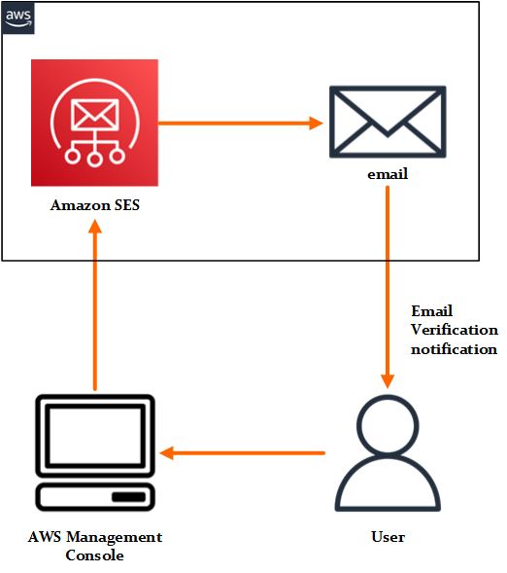

Figure 3-52: Introduction to Amazon Simple Email Service SES

Implementation Steps

1. Create an Email Identity using SES.

2. Verify the Email address.

3. Send a Test Email.

### Solution

|  |
| --- |
| **Step 1: Create an Email Identity using SES**  1. Log in to the **AWS Management Console**.  2. Go to **Services** and click on **Business Applications**. Then select **Amazon Simple Email Service.**    3. Click on the **Create identity** button.    4. Select the Identity type as the **Email address**.    5. In the **Email address,** enter your valid **Email address**.    6. Leave everything as default. Click on the **Create identity** button.    7. Hence, you have successfully created an Email Identity using SES, but you can see that the **Identity Status** on the email is **Unverified.** |

|  |
| --- |
| **Step 2: Verify the Email Address**  1. AWS sends a confirmation email to the email you provided above. Log in to your mailbox, and see a mail from Amazon Web Services.    2. Once you click the link, you will be routed to the success page.    3. Go to the **SES Email Address page** and **refresh the page**. You can see that the Verification status is **Active**. |

|  |
| --- |
| **Step 3: Send a Test Email**  1. Send a test email to the same email address. Click on **Send Test Email** button.    2. Select **Formatted** as the email format.    3. Your email address is present by default in the **From-address**.    4. Select the **Custom** scenario.    5. In **Custom recipient,** give the same **email address** for testing purposes.    6. In **Subject,** enter **Sending a Test Email.**    7. In the **Body,** type any text as you wish.    8. Leave everything as default. Click on the **Send test email** button.    9. Hence, you have successfully sent a test email. Verify the mail received in your inbox. If it is not present there, check for it in **Spam**. |

## Lab 3-19: Introduction to Simple Queuing Service (SQS)

### Lab Prerequisites

* Familiarity with basic AWS Cloud Computing concepts and terminology
* An AWS account with an active subscription

### Service Introduction

Amazon SQS has various advantages over developing your message queue management software or utilizing commercial or open-source message queuing solutions, all involving substantial upfront work for creation and implementation.

These options need regular hardware maintenance as well as system management resources. The difficulty of creating and operating these systems is exacerbated by the requirement for redundant message storage, which guarantees that messages are not lost if hardware fails.

Amazon SQS, on the other hand, involves no administrative cost and trim configuration. Amazon SQS operates at an enormous scale, processing billions of messages daily. Without any setup, you may increase or decrease the traffic sent to Amazon SQS. Amazon SQS offers exceptionally high message durability, providing you and your stakeholders with additional assurance.

### Case Study – USEN Delivers Low-Cost Piped Music Wirelessly Using AWS SQS

Background

USEN began in 1961 and built its business by providing retailers with background music (BGM). Around 800,000 restaurants, beauty salons, and other clients use the service in Japan, and 50,000 new companies join up each year. The capacity of USEN's subscription-based B2B model to manage everything from hardware and software development to infrastructure building and content acquisition is a crucial asset.

The new U-MUSIC idea from USEN is an AI-based BGM streaming service that uses wireless transmission rather than cables and satellites. The system comprises a customized set-top Wi-Fi box that enables in-store connectivity over an L2 wireless internet network (MVNO) for commercial use. The setup is completed with a tablet for remote control and a built-in BGM playback platform, which eliminates the need for retailers to establish a new physical connection.

Business Challenge

USEN intends to extend U MUSIC's operations to give services to major chain retailers and expand its client base. In addition, the business develops an AWS-based platform to enable a variety of new IoT Platform services, such as wireless communications (U AIR), IP phones (U PHONE), security cameras, and analytics (U EYES). With the U EYES Cloud Premium service presently in the works. As the 5G wireless future approaches, USEN is also working to tackle shop management issues.

Proposed Solution

USEN music streaming platform also uses Amazon Simple Queue Service (Amazon SQS). Amazon SQS gathers channel information generated by a USEN team, millions of song data on music management servers, weather information, and store visitor characteristics, all stored on Amazon DynamoDB. An AI engine utilizes this data every hour to build playlists for each store in five minutes. Music is then streamed from a data center server based on these playlists. By automating activities that were previously conducted manually by editing teams, instant delivery of BGM suited for clients is made possible.

Lab Diagram

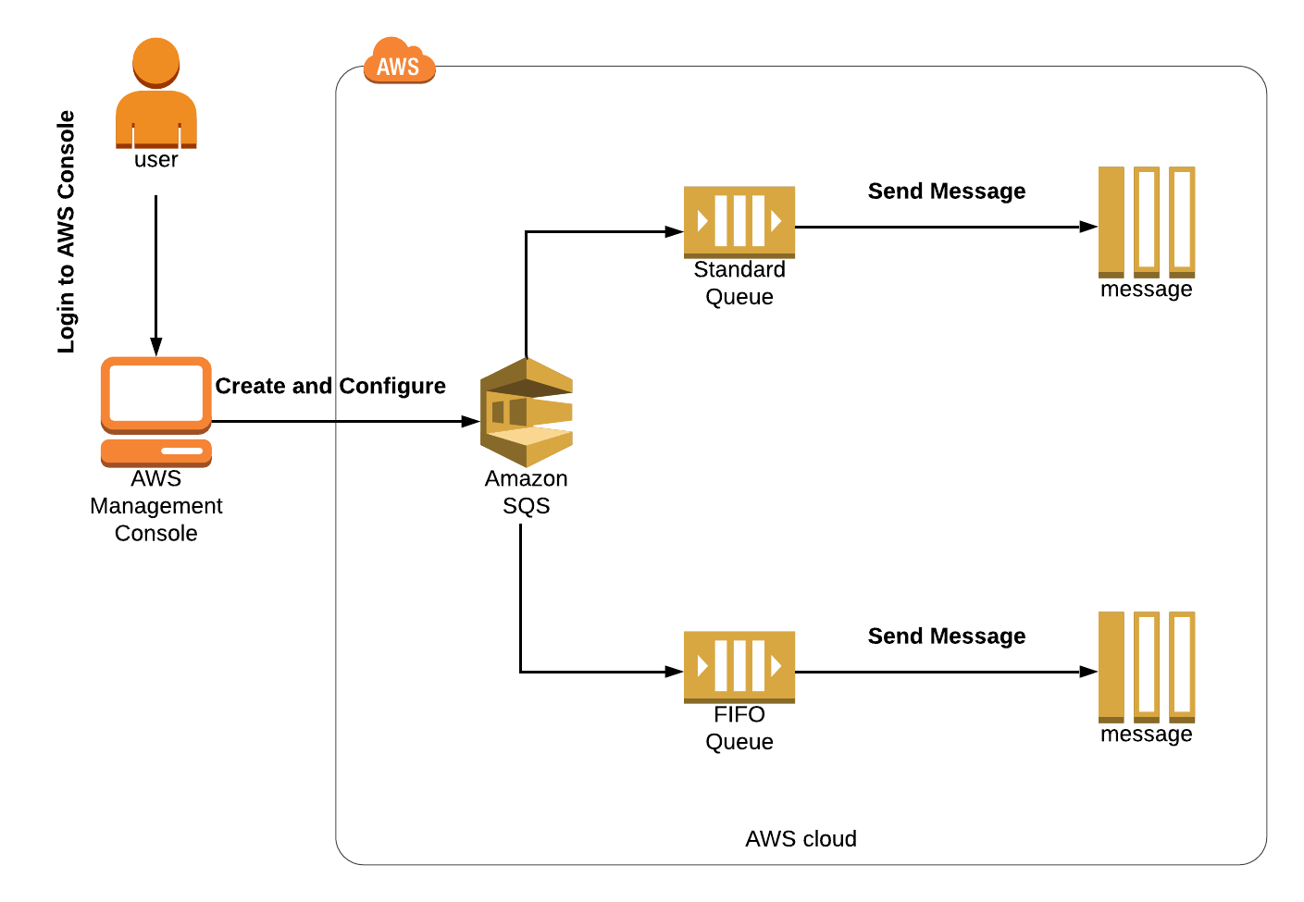

Figure 3-54: Introduction to Simple Queuing Service (SQS)

Implementation Steps

1. Create FIFO and Standard Queue using the Console
2. Configure Long Polling, Long Polling & Delay Queue
3. Configure & Verify Purge Queue for standard FIFO & Standard Queue

### Solution

|  |
| --- |
| **Step 1: Create FIFO and Standard Queue using the Console**  1. Log in to the **AWS Management Console.**  2. Go to **Services** and click on **Application Integration**. Click on **SQS**.    3. Click on the **Create queue** button.    4. Select the type **FIFO.**    5. Enter the name **AWSQueue.fifo**. The name of a FIFO queue must end with the .fifo suffix.    6. Scroll down, leaving everything as default. Click on the **create queue** button.    7. Hence, you have successfully created SQS FIFO Queue.    8. Again, click on the **Create queue** button.    9. Select the type **Standard**.    10. Enter the name **AWSQueue** for the standard queue.    11. Scroll down, leaving everything as default. Click on the **create queue** button.    12. Hence, you have successfully created SQS Standard Queue.    13. Click on the **AWSQueue.fifo** to get detailed information about all the essential parameters, including **ARN**, **Name,** and **URL** of the queue.    14. Click on **Send and receive messages**.    15. To send messages, enter the **My first queue message** under the **Message body.**    16. Under the **Message group ID**, enter **group123.**    17. Under the **Message deduplication ID,** enter **id23**.    18. Click on the **send message** button.    19. After sending the message, you can see that the **Messages available** change to 1.    20. To get all your messages, click on **Poll for messages** in the **Receive messages section**.    21. Click on the **message** to see its body.    22. Hence, you have successfully sent and received FIFO SQS Queue messages in the Console.    23. Select the **AWSQueue** standard queue.    24. Then click on **the Send and receive messages** button.    25. Enter the My first standard message queue under the Message body to send a message**.** Then click on the **Send message** button.    26. After sending the message, you can see that the **Messages available** change to 1.    27. To get all the messages we have sent, click on **Poll for messages** in the **Receive messages section**.    28. Click on the **message** to see its body.    29. Hence, you have successfully sent and received Standard SQS Queue messages in the Console. |

|  |
| --- |
| **Step 2: Configure Long Polling, Long Polling & Delay Queue**  1. Select the **AWSQueue.fifo** queue.    2. Click on the **Edit** button.    3. Update the **Default Visibility Timeout** parameter to **5** **minutes**.    4. Update the **Delivery Delay** parameter to **60 seconds.**    5. Update the **Receive Message Wait Time** parameter to **10** **seconds**.    6. Scroll down and click on the **Save** button. |

|  |
| --- |
| **Step 3: Configure & Verify Purge Queue for standard FIFO**  1. Select **AWSQueue.fifo** FIFO SQS Queue.    2. Click on the **Actions,** then click on **Purge**.    3. Once you select the **purge** option, it asks for a confirmation. Enter the phrase **purge** and click on the **purge** button.    4. To verify if a purge has occurred on the fifo queue, click on **send and receive messages** button.    5. Click on the **Poll for messages** button, and it shows no messages. It signifies that the purge was successful. |